JRAHS Trial HSC 2006 Extension 2

Question 1 (15 Marks) Marks

(a) Find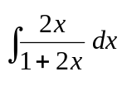. 2

(b) How many different ways are there of choosing a cricket 11 from a team of 15 3
players, if there can only be at most, one of the 2 Lee brothers and 2 of 3 Abey
brothers?

(c) Find 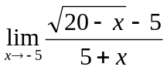. 2

(d) Find the sum of all the coefficients of powers of z in the expansion (1 + z)⁸. 2

(e) (i) Find the equation of the tangent to the hyperbola 3x² – y² = 12 at the point 3
T(x₁, y₁).

(ii) This tangent meets the line d (x = 1) in the point M. Prove that FM ⊥ FT, 3
where F is the focus (4, 0).

Question 2 (15 Marks) START A NEW PAGE

(a) (i) Express 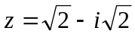in modulus – argument form. 2

(ii) Hence, write z²² in the form of a + ib, where a and b are real. 3

(b) If a, b, c are real and unequal and that a² + b² > 2ab deduce that

(i) a² + b² + c² > ab + bc + ca 2

(ii) If a + b + c = 6 show that ab + bc + ca < 12 2

(c) Let I_{n} = 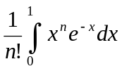 for n ≥ 0.

(i) Use integration by parts to show that I_{n} = 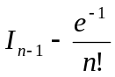 3

(ii) Hence, evaluate I₄. 3

Question 3 (15 Marks) START A NEW PAGE Marks

(a) The diagram below is a sketch of the function y = f(x).

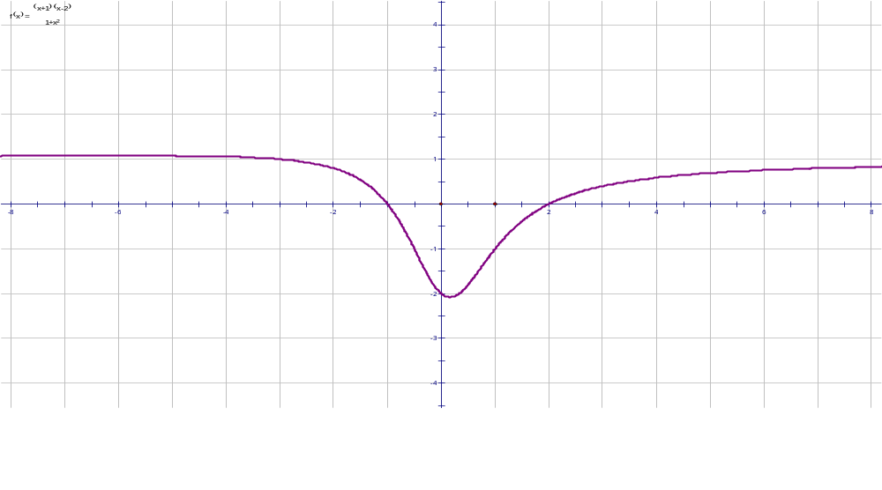

On separate diagrams sketch neatly:

(i) y = |f(x)| 2

(ii) y = e^{f(x)} 2

(iii) y = ln(f(x)) 2

(b) Reduce the polynomial x⁴ – 2x² – 15 over the rational and the complex field. 2

(c) If z₁, z₂ are 2 complex numbers such that |z₁ + z₂| = |z₁ – z₂|. 4
With the aid of a diagram, show that arg (z₁) and arg (z₂) differ by either
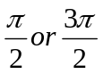.

(d) Evaluate 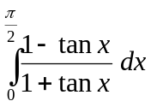. 3
Question 4 (15 Marks) START A NEW PAGE Marks

(a) A string 50 cm of length can just sustain a weight of mass 20 kg without 3
breaking. A mass of 4 kg is attached to one end of the string and revolves
uniformly on a smooth horizontal table; the other end is being fixed to a
point on the table.

Find the greatest number of complete revolutions the mass can make in a
minute without breaking the string. [Use acceleration due to gravity as 9.8 m/s²]

(b) Evaluate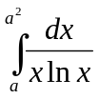, leaving your answer in simplified, exact form. 3

(c)
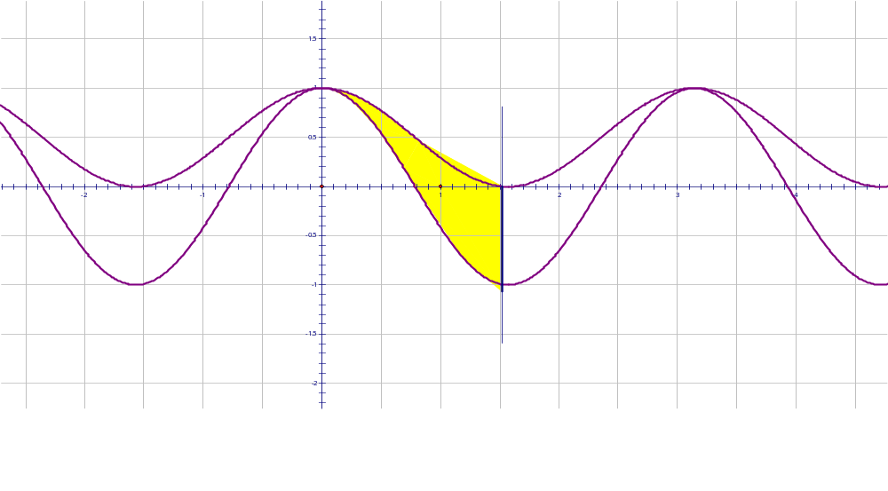
y = cos²x
y = cos2x
x = 

The area between the graphs of y = cos²x and y = cos2x for 0 ≤ x ≤ 6
and x = is rotated about the y – axis. By considering cylindrical shells, find
volume of revolution of the solid formed, in terms of π.

(d) Use the properties of odd and even functions to evaluate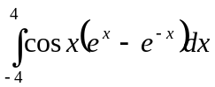. 3

Question 5 (15 Marks) START A NEW PAGE

(a) (i) Find A and B for which 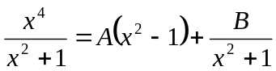. 2

(ii) Show that this result may be used in the integration of the function x³tan⁻¹x. 5
Hence, evaluate the integral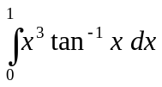.

(b) A particle P is projected vertically upwards from the surface of the Earth with
initial speed u. The acceleration due to gravity at any point on its path is inversely
proportional to the square of it’s distance from the centre of the Earth.
P
x
R
O
Diagram not to scale
(i) Prove that the speed v in any position x is given by v² = u² – 2gR + 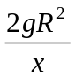, 4
where R is the radius of the Earth and g is the acceleration due to gravity at
the surface of the Earth.

(ii) If u = 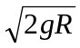, find the time taken to reach a height 3R above the surface 4
of the earth, in terms of g and R.

Question 6 (15 Marks) START A NEW PAGE Marks

(a) A total of five players is selected at random from four sporting teams. 4
Each of the teams consists of 10 players numbered from 1 to 10. What is the
probability that the five selected players contain at least four players from the
same team? Clearly explain your answer.

(b) A particle P of mass m is attached by two equal, light inextensible strings
of length l, to two points Q and S, distant h units apart in the same vertical line;
S is directly below Q. P rotates in a horizontal circle with uniform angular
velocity, ω.
P
Q
S
h
l
O
Diagram not to scale
- Prove that the tension in the string PQ is ml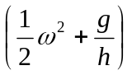 where g is the 5
acceleration due to gravity.

- Find the tension in the string PS. 1
- Show that for both strings to remain stretched then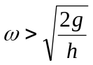. 2
- If the tensions in the string are in the ration of 2:1, find the period of the 3
motion of the particle.

Question 7 (15 Marks) START A NEW PAGE Marks

(a) α, β, γ are non – zero roots of the equation x³ + px + q = 0.
Find the equation whose roots are

- α ³, β ³, γ ³ 3

- 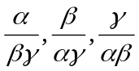 4

(b) The diagram below shows the hyperbola xy = c². The point P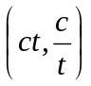 lies on the
curve, where t ≠ 0. The normal at P intersects the straight line y = x at N.
O is the origin.
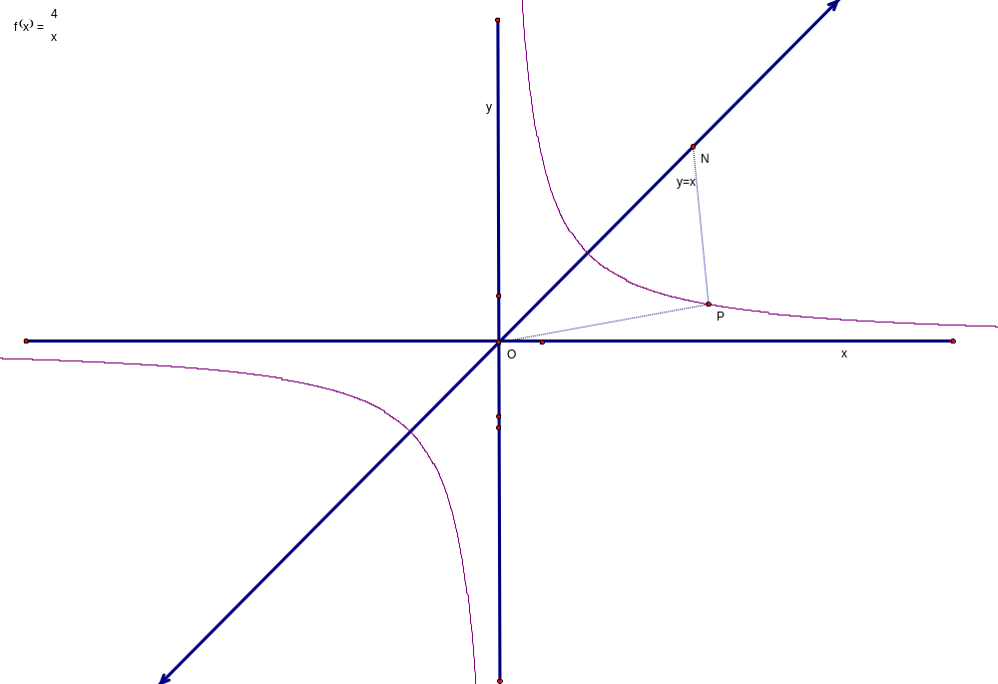
y
(i) Prove that the equation of the normal at P is 1
y = 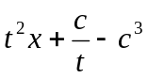.
(ii) Find the coordinates of N. 1
(iii) Show that ∆OPN is isosceles. 2

(c) (i) Draw a neat sketch of the graph of y = 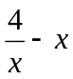. 2
(ii) Draw a neat sketch of the curve y = 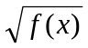. 2
Question 8 (15 Marks) START A NEW PAGE Marks
(a) Ben’s Hot Wheel travels along an inclined ramp to jump over a truck. The Hot
Wheel travels at an initial speed V m/s inclined at an angle θ to the horizontal at O,
and acceleration due to gravity is g m/s².
The Wheel’s trajectory is given by y = 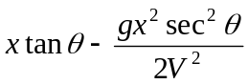.


θ

- Write this equation in the general form of a parabola: (x – h)² = 4a(y − k), 3
where a, h, k are constants.

- Calculate the angle of projection, θ, if the range is three times the width of 3
the truck and the top of the truck passes through the focus of equation in part (a).

(b) Given p and q are positive real numbers,

(i) Prove that: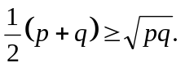 1
- Hence, deduce that: 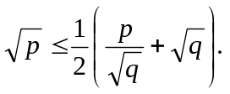 1

Question 8 Part (c) continued on the next pag

(c) Given are positive real numbers,
where are
such that a₁, a₂, …….., a_{n} > 0, b₁, b₂, …….., b_{n} > 0 and 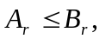 for r = 1, 2, 3, …, n.

(i) Prove, by mathematical induction for n = 1, 2, 3, …, that: 3

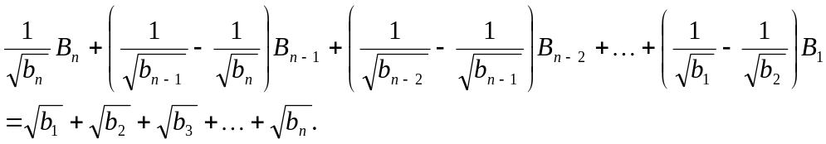

- Hence, given: 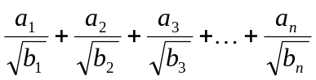 =
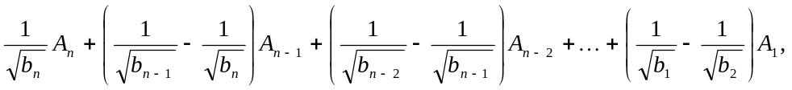

show that: 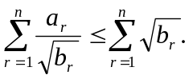 1

(iii) Deduce that: 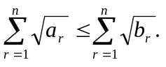 3

